TEST 2: DANIEL CRISP

CPSC 131

#Q1

MATLAB CODE: NewtonRaphson.m

clear; clc;

script = 'NewtonRaphson';

syms t;

f = 2+9\*t-4.9\*t^2-t;

fdifft = diff(f,t);

%fNR = t0-(f/fdifft);

x = 1;

for i=1:6

xnew = x-(subs(f,t,x)/subs(fdifft,t,x));

fprintf('%d\t%f\t%f\t%f\t%f\n',i,x,subs(f,t,x),subs(fdifft,t,x),xnew);

x = xnew;

end

i t f(t) dfdt xnew

1 1.000000 5.100000 -1.800000 3.833333

2 3.833333 -39.336111 -29.566667 2.502912

3 2.502912 -8.673097 -16.528542 1.978178

4 1.978178 -1.349197 -11.386143 1.859683

5 1.859683 -0.068801 -10.224896 1.852954

6 1.852954 -0.000222 -10.158954 1.852933

MATLAB OUTPUT: starting with t = 1, and then for starting at t = -4.

i t f(t) dfdt xnew

1 1.000000 5.100000 -1.800000 3.833333

2 3.833333 -39.336111 -29.566667 2.502912

3 2.502912 -8.673097 -16.528542 1.978178

4 1.978178 -1.349197 -11.386143 1.859683

5 1.859683 -0.068801 -10.224896 1.852954

6 1.852954 -0.000222 -10.158954 1.852933

i t f(t) dfdt xnew

1 -4.000000 -108.400000 47.200000 -1.703390

2 -1.703390 -25.844650 24.693220 -0.656760

3 -0.656760 -5.367622 14.436253 -0.284945

4 -0.284945 -0.677409 10.792461 -0.222178

5 -0.222178 -0.019304 10.177346 -0.220281

6 -0.220281 -0.000018 10.158757 -0.220280

It is clear from the matlab output that the function converges at t = 1.8529

seconds, and (assuming time could be negative) at t = -0.22028 seconds.

#Q2: Rocket Plots

MATLAB CODE: rocket.m

% Clean, clear workspace, reset scriptval for script recall.

clear; clc;

script = 'rocket.m';

% Iteration info

start = 0;

stop = 25\*60;

step = 30;

steps = (stop-start)/step;

% Variables

g = 9.81;

cd = 0.55;

Ft = 4.2\*10^6;

cf = 1.4\*10^(-3);

mNoFuel = 23500;

t = linspace(start,stop,steps);

m(1) = 258500;

v(1) = 0;

for i = 2:steps

m(i) = m(i-1) - (cf\*m(i-1))\*(t(i) - t(i-1));

v(i) = v(i-1) + ((Ft/m(i-1)) - g - (cd/m(i-1))\*v(i-1)^2)\*(t(i)-t(i-1));

end

subplot(1,2,1); plot(t,m,'-r');

title('Mass vs Time'); xlabel('time (s)'); ylabel('Mass (kg)');

grid on

subplot(1,2,2); plot(t,v,'-.b');

title('Velocity vs Time'); xlabel('time (s)'); ylabel('Velocity (m/s)');

grid on

fprintf('\nThe rocket weighs %3.4f kg, and %3.2f of that is fuel.\n',m(i),m(i)-mNoFuel);

OUTPUT:

The rocket weighs 30221.9108 kg, and 6721.91 of that is fuel.

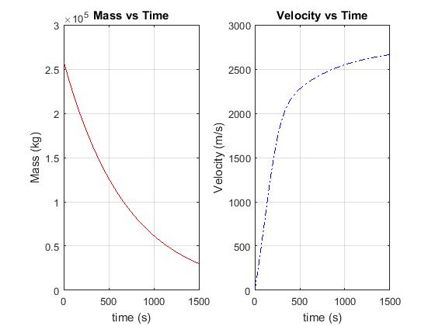

#Q3: Shift Array

MATLAB CODE: shifter.m

% Clean and clear workspace, reset scriptname for recall

clear; clc;

script = 'shifter';

% Shift num, and array

num = 3;

a = [10, 30, 50, 60 70, 80 19]

% Create new shifted array

len = length(a);

aNew = [a(num+1:len),zeros([1,len-num-1])]

OUTPUT:

a =

10 30 50 60 70 80 19

aNew =

60 70 80 19 0 0 0